**The Great Examiner: Identity and Work**

**Introduction**

Exams are a significant and unavoidable element in the lives of young people throughout their time at school, university, and beyond. The social pressure and desire to do well can seem overwhelming and all consuming. As Christians we need to rightly engage with these milestones in the lives of young people, while keeping our eyes focussed on the hope we have in Christ. Are you approaching or in the middle of exams? I hope this will be useful in considering what it looks like to glorify God as you prepare, take, and press on after, your exams. Are you in a stage of life in which exams are a distant memory? I hope the ideas here will still be relevant in your work and context, and you can use it to encourage those in your churches who are facing formal assessments of some kind.

There are two halves to this post – you can find the second half here. In this post we consider ideas of personal identity and work, in the context of student life and exams; and what the truth of the gospel of Jesus Christ has to speak into it. The second part focusses on a passage from Philippians, and looks more specifically and practically at honouring God in exam season.

This material is drawn from spending time in God’s word and applying it to my own experience of school and university – trying to think through what I saw done well and done badly, and what it would have been useful to know during my time at university. It was originally put together as two seminars for students at Cambridge university heading into the dreaded “exam term,” but has been edited to be appropriate for a wider audience and reading in prose.

**Finding our Value**

All of us long to be valued. To feel as if we’re contributing something, worth something, part of something. We search for that value in ourselves and in validation from others. It’s something that’s self-evident as we look around us. We see ambitious people striving for success in business, struggling people searching for their value through therapy, vain people seeking to glorify themselves on social media.

The trouble is that as we search for this value in ourselves and validation for others, we have no confidence or assurance. We cannot read minds, and even if we could, would we even understand what was going on? When we’re honest we have to admit that we do not even understand ourselves, let alone the minds of others. In the words of the apostle Paul “I do not understand what I do. For what I want to do I do not do, but what I hate I do” (Romans 7:15). We cannot work these things out for ourselves with the assurance we so desire. Our solution, then, is to construct external measure of value, something more objective than opinions of ourselves and others. We define ourselves by class background, ethnicity, exam results and sexuality. We form tribes around political parties, social causes, and football teams. Throughout school and university, we’re told our value is in who we are, yet all of our time, pressure, and direction is oriented towards exams and coursework; and we look to these to measure how successful was that stage of life. As fallen humans we are self-worshippers, and as self-worshippers we try to ‘prove’ our value with ‘objective’ measures. Of course much of this is cultural, societal, and subconscious. Yet it forms a great deal of what we do and how we behave.

**The Christian Perspective**

These things are still not sure. They are not truly objective. Yes, exams and tests try to be, but they don’t but they don’t test perfectly, they don’t perfectly predict future success or current ability. We search for absolute value in a subjective world. As Christians we can look to something beyond this subjective world. We look outside of ourselves not to something tainted by sin and subjectivity, but to God’s very own words. God does not lie. He is truth. He is authoritative over all things as Creator and Redeemer. He knows each of us and has revealed Himself to us. We want Scripture to have the final say in shaping and defining our understanding of ourselves and our understanding of reality. We want the authority of the text to define our identity. Because in the Bible we have objective truth. We expect that our identity and value can be fully and properly defined as we hear what the one who made us has to say about us.

So, what does the Bible have to say about who we are?

**In the context of preparing for exams and coursework**

These truths have powerful implications in the context of exams and assessments. Here are 3 things to remember.

1. Remember what is objectively true about you, as revealed in the Bible, and against what is only subjective.

In the weeks approaching exams and deadlines, your focus will be drawn more and more to how revision is going, how many hours you’ve spent studying, and how little of the course you know. And this will begin to shape how you think about yourself more generally. It is of course good and useful to talk about what is on our mind, what is consuming our time, and there is a place for listening to and supporting one another in that. But be careful spending extended periods only thinking and talking about subjective measures drawn from the world. Instead in the exam term be deliberate in shifting thoughts and conversations in a vertical, Godward direction – ask “what do the truths of scripture have to say about this – the things we looked at above?”. The work that you’re engaging with, the time that you dedicate to studying, the outcomes of that work – consider how the fact that you are an image bearer, created for a purpose, living in a fallen world but redeemed in Christ and now God’s sons and daughters changes how you think about these things. Remember what is objectively true about you.

1. Remember that the work we do in preparation for exams, coursework, and whatever else derives its value from you as an image bearer, not the other way round.

The way things are set up with exams, coursework, and assessments - and even the way we’re taught to handle pieces of literature and scientific papers - makes it look as if the work has some inherent value, which can be measured and given a score, and that reflects back on you, giving you value. So we get turned around and think we get our value from the amount and quality of the work we produce. No. Your work has value because it is produced by you, an image bearer who has been redeemed in Christ. The outcome of your labours, the understanding in your mind, the essays and equations, have value only as they point to a creator made in the image of the Creator. This is a principle that’s true everywhere – nature is beautiful because it declares the glory of the creator, our relationships are wonderful in the way they reflect the love God; and your work has value in the way it reflects a creator made in the image of the creator. In the exam season, as you work you are obeying the mandate given to humanity at Eden, and which will carry on into eternity. God is pleased as we work for him with all our hearts, not as for human masters. With this in mind our work becomes an act of worship. Remember that your work derives value from you.

1. Remember that although you may be concerned for many things, God in His wisdom has only given you responsibility for some of it.

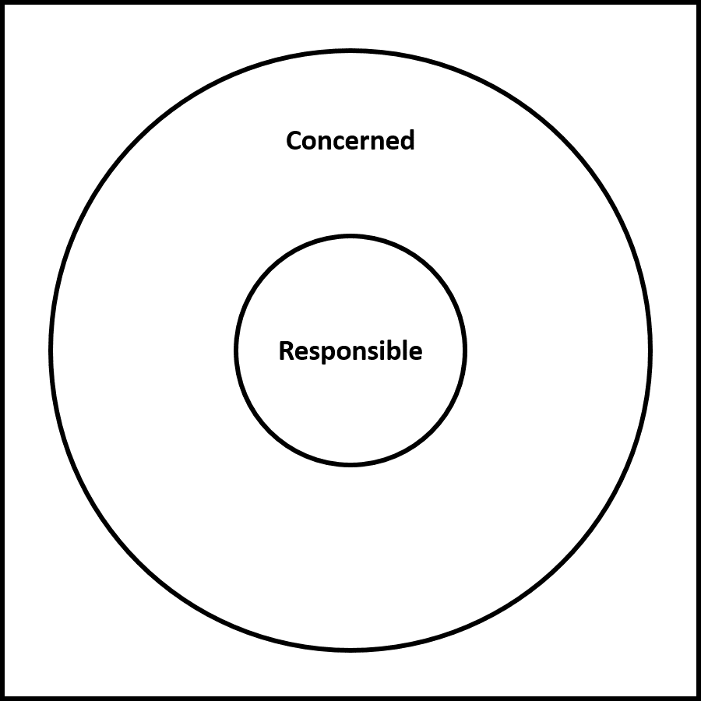God created us as finite creatures - He alone is infinite. We cannot be responsible for everything, and do not need to be because God is sovereign. God has placed us each in a time and place, with people around us and things for which he has given us responsibility. Have a look at the diagram here. The large circle contains all the things we are concerned about. There might be a great deal of things here – from world hunger and social justice, to whether George RR Martin is ever going to finish writing the Game of Thrones books. It’s rights and appropriate to be concerned for many things, and to bring the things on our mind to God in prayer.

Yet, within our set of concerns should be a smaller set of things for which God has given us responsibility. These include responsibilities to support our families and friends (although their actual wellbeing is only a concern), keeping ourselves healthy, working hard and growing closer to God. Thinking about exams, our concerns might include what the questions will be, whether we’ll be ill on the day, and ultimately what the results will be. These things are ultimately beyond our control. We do have responsibility to work well, to eat well, to rest and socialise, and to continue growing in Godliness. Maybe you could draw out the diagram and fill things in for your particular situation? Use the concerns to fuel your prayer, but trust that God has those covered! Use the responsibilities to rightly prioritise and orient your own time to God’s glory.

Humanity as a whole was created as vice-regents over creation, but to each of us now, in the situations we find ourselves in, we are called to look at it with the eyes of faith and be the best student we can be, the best in our current situation, to the glory of God.